

Avishayes Primary School and Early Years Centre
Attendance Policy

Responsibility: | Governing Body
Reviewed: | September 2025
Next review date: | September 2026
Key legislation: | Equality Act 2010  Education Act 2006 section 7
This policy should be read in conjunction with:
Keeping Children Safe in Education (Part 1)
Special Educational Needs (SEN)
Equal Opportunities Policy
ICT Acceptable User & Social Media Policy
Statutory safeguarding guidance (2016)
Children and Social Work Act (2017)
‘Working together to improve school Attendance’ Government Guidance

Introduction

Good habits which are established early in life, continue into adulthood and help to develop good working routines and relationships, which in turn lead to personal success and self-esteem. Good attendance at school underpins success in all areas of the curriculum. For the pupils of Avishayes School to gain the greatest benefit from their education it is vital that they attend regularly, be at school, on time, every day the school is open unless the reason for the absence is unavoidable.

It is very important therefore that parents/carers make sure that their child attends regularly and this Policy sets out how working in partnership with parents/carers this will be achieved. This policy is in line with other schools in the area and reflects county and national policy. All pupils should achieve at least 96% attendance, with the aim of 100%.

Improving attendance is everyone’s business. The barriers to accessing
education are wide and complex, both within and beyond the school gates, and are
often specific to individual pupils and families. The foundation of securing good
attendance is that school is a calm, orderly, safe, and supportive environment where all
pupils want to be and are keen and ready to learn.

Some pupils find it harder than others to attend school and therefore at all stages
of improving attendance, schools and partners should work with pupils and parents to
remove any barriers to attendance by building strong and trusting relationships and
working together to put the right support in place.

Why regular attendance is so important
Any absence affects the pattern of a child’s schooling and regular absence will seriously affect their learning. Any pupil’s absence disrupts teaching routines so may affect the learning of others in the same class. This is essential for pupils to get the most out of their school experience, including their attainment, wellbeing, and wider life chances. The pupils with the highest attainment at the end of key stage 2 and key stage 4 have higher rates of
attendance over the key stage compared to those with the lowest attainment. At
KS2, pupils not meeting the expected standard in reading, writing and maths had an
overall absence rate of 4.7%, compared to 3.5% among those meeting the expected
standard.

Ensuring a child’s regular attendance is the legal responsibility of parents/carers and permitting absence from school without a good reason creates an offence in law and may result in prosecution.

Parental/Carers responsibilities and the need to promote regular attendance.

Where parents decide to have their child registered at school, they have an
additional legal duty to ensure their child attends that school regularly. This means their
child must attend every day that the school is open, except in a small number of
allowable circumstances such as being too ill to attend or being given permission for an
absence in advance from the school.

The Education Act 2006 states that all children should attend school regularly and punctually. Section 444 of the Act says:

If a child of compulsory school age who is a registered pupil at a school fails to attend regularly at the school his/her parent is guilty of an offence.

Section 7 of the Act states that every parent/carer of a child of compulsory school age shall cause him/her to receive efficient fulltime education suitable to his /her age, ability and aptitude and to any special educational needs he /she may have, either by regular attendance at school or otherwise.

To support parents and carers focus on this Avishayes School will:

- Follow the guidance set out by the Government ‘Working Together to Support School Attendance’ document
- Report to you regularly on how your child is performing in school, what his/her attendance and punctuality rate is and how this relates to his/her attainment;
- Celebrate good attendance by displaying individual achievements on a half termly basis by awarding 100% attendance certificates, displaying children’s photographs with good attendance in the school hall etc.
- Develop and maintain a whole school culture that promotes the benefits of high attendance.
- Have a clear school attendance policy which all staff, pupils and parents understand.
- Accurately complete admission and attendance registers and have effective day to day processes in place to follow-up absence.
- Regularly monitor and analyse attendance and absence data to identify pupils that require support with their attendance and put effective strategies in place.
- Build strong relationships with families, listen to and understand barriers to attendance and work with families to remove them.
- Share information and work collaboratively with other schools in the area, local authorities, and other partners when absence is at risk of becoming persistent or severe.

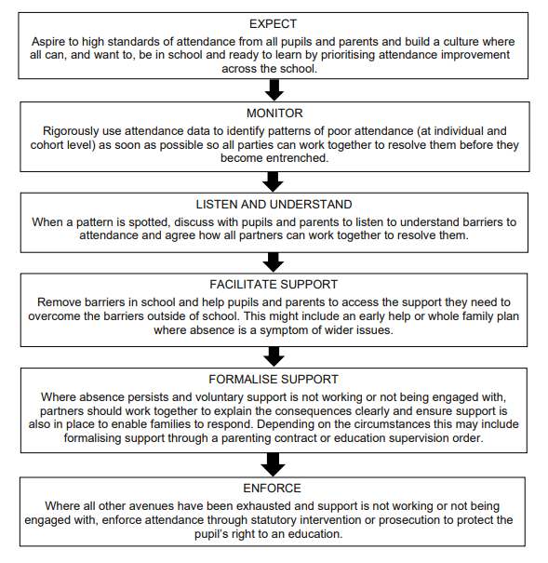
Understanding types of absence
Every half-day absence from school has to be classified by the School (not by parents), as either AUTHORISED or UNAUTHORISED. This is why information about the cause of any absence is always required, preferably in writing. Authorised absences are mornings or afternoons away from school for a good reason like illness, emergencies or other causes that the school feels were appropriate. Unauthorised absences are those which the school does not consider reasonable and for which no “leave" has been given. This type of absence can lead to the Authority using sanctions and/or legal proceedings.

This type of absence includes:
• Parents/carers keeping children off school unnecessarily
• Truancy before or during the school day
• Absences which have never been properly explained or evidenced
• Pupils who arrive at school too late to get a mark
• Shopping, looking after other children or birthdays
• Day trips and holidays in term time

Whilst pupils may be away from the School because they are ill, sometimes they can be reluctant to attend School. The administration team will ask if the child has been suffering any bullying behaviours. Any problems with regular attendance are best sorted out between the School, the parents/carers and the child. If your child is reluctant to attend, it is never better to cover up their absence or to give in to pressure to excuse them from attending. This gives the impression that attendance does not matter and usually makes things worse. Make sure that you let the school know if your child is reluctant or refusing to attend school as we may be able to help to resolve the problem.

Children with medical conditions affecting attendance
Pupils with long term illnesses or other health needs may need additional support to continue their education, such as alternative provision provided by the local authority.
Local authorities are responsible for arranging suitable education for children of
compulsory school age who, because of health reasons, would otherwise not receive
suitable education. Please see further information on supporting pupils with medical
conditions at school.

Persistent absenteeism (PA)
A pupil becomes a ‘persistent absentee’ (PA) when they miss 10% or more schooling across the school year for whatever reason. Absence at this level is doing considerable damage to any child’s educational prospects and the School needs parents’ and carers’ fullest support and co-operation to tackle this.

The school monitors all absence thoroughly. Any case that is seen to have reached the PA mark or is at risk of moving towards that mark is given priority and parents will be informed of this immediately. PA pupils are tracked and monitored carefully by the school attendance team. This team is made up of the Headteacher, the SENCo and the Administration Assistants. It will also be normal practice for the School to require Parents or carers to seek medical evidence from their child’s doctor to validate any absence due to illness if there is a historical or an ongoing pattern of absence. PA cases may also be made known to the Education Safeguarding Officer (ESO).
.
Absence Procedures
If your child is absent parent/carers must:
• Contact the school as soon as possible on the first day of absence by phoning the School and keeping the School informed of further absences if the absence lasts longer than one day (01460 63050)
• Send a note in on the first day pupil return with an explanation of the absence or parents/carers can call into school reception if they prefer.

If your child is absent the school will:

- Text or telephone you on the first day of absence if the school has not heard from you (it is therefore vital that the school has up to date contact details)
- Write to parent/carers to express the school’s concerns about the level of absence and/or the fact that the parent/carer has not contacted the school to explain the reason for the absences (See Appendix 3 for our Parents and Carers Guide)
- Invite parent/carers in to discuss the situation with the Headteacher and the Attendance Team if absences persist
- The School will also refer the matter to the Education Safeguarding Service if the number of unauthorised absences exceeds 10 sessions in 12 weeks.

The Use of Penalty Notices and Warning Penalty Notices
Avishayes Primary School will follow Somerset Local Authority’s Code of Conduct regarding the issuing of Penalty/Warning Penalty Notices. A penalty notice may be issued for unauthorised term time leave of ten continuous sessions (five days) or more and your child’s attendance falls below 96%.

In cases where there are ten sessions of intermittent absence the school can decide to issue a warning penalty notice. This decision will be at the discretion of the Headteacher on a case by case basis. See Guidance https://www.somerset.gov.uk/education-and-families/school-attendance-and-children-missing-education

Telephone numbers
There are times when the school needs to contact parents/carers about lots of things, including absence, so the school needs to have parent/carers contact numbers at all times. Please help the school to help parents/carers and children by making sure that the school always has an up to date number – if the school does not then something important may be missed. There will be regular checks on telephone numbers throughout the year.

Education Safeguarding Services
Parents/carers are expected to contact the School at an early stage and to work with the staff to resolve any problems together. This is nearly always successful. If difficulties cannot be sorted out in this way, the School may refer the pupil to the Education Safeguarding Officer from the Local Authority or discuss the issue.

If other ways of trying to improve the pupil’s attendance have failed and unauthorised absences persist, ESOs can request sanctions from the Local Authority such as Penalty Notices or prosecutions in the Magistrates Court. Full details of the options open to enforce attendance at the School are available from the School or the Local Authority.

Lateness
Poor punctuality is not acceptable. If your child misses the start of the day they can miss work and do not spend time with their class teacher getting vital information and news for the day. Late arriving pupils also disrupt lessons.

How we manage lateness
- The day starts for most students at 8.50am and the school expects pupils to be present at that time. (Some pupils may have different timetables as part of their Individual Education/Health Care Plan. These will have been agreed with parent/carers)
- Registers are marked by the Class teacher at 8.55am and your child will receive a late mark if they are not in by that time.
- At 9.00 am the registers will be closed. In accordance with the regulations, if your child arrives after that time they will receive a mark that shows them to be on site, but this will not count as a present mark and it will mean they have an unauthorised absence. This may mean that you could face the possibility of a Warning Penalty Notice/Penalty Notice if the problem persists.

If your child has a persistent late record you will be asked to meet with the Headteacher/ SENDCo to resolve the problem, but parent/carers can approach the school at any time if parent/carers are having problems getting their child to school on time.

Holidays and unauthorised leave in term time.
Taking holidays in term time will affect a child’s schooling as much as any other absence and the school expects parents/carers to help the school by not taking children away in school time. Remember that any savings parent/carers think that they may make by taking a holiday in school time are offset by the cost to a child’s education.

There is no automatic entitlement in law to time off in school time to go on holiday. In line with Government Policy regulations the School may not grant any leave of absence during term time except for exceptional circumstances.

Religious observance.
- a maximum of 3 days absence is allowed for religious observance.

Medical, dental or hospital appointments.
- The School encourages these appointments to take place out of school time, where this is not possible the School will require proof of the appointment in order to authorise the appointment. The School will also require children to return to School for the remainder of the session following the appointment.

From September 2013 the education attendance service and Local Authority made important changes to the code of conduct regarding unauthorised leave taken during term time. The details of these changes are included in
Appendix 1 of this policy.

School targets
The School has targets to improve attendance and children have an important part to play in meeting these targets. The expected level of attendance for the school is at least 96% attendance and the School will keep you updated regularly about progress to this level and how the attendance of individual children compares. The School knows that good attendance is the key to successful education. Through the school year the School monitors absences and punctuality to show the School where improvements need to be made.

Staff responsibilities
Those people responsible for attendance matters in the School are:
- All staff who sensitively promote the importance of regular attendance and act as good role models in terms of punctuality and attendance
- Teaching staff who record absences accurately; liaise with the Parent and family support adviser; contact parent/carers if pupils are unwell; raise concerns about a child’s attendance with the Headteacher
- Headteacher who considers any requests for leave during term time for exceptional reasons; leads the school’s attendance Team; liaises with outside agencies; contacts parents/carers if a child’s attendance is a concern, monitors pupils’ attendance and punctuality; makes referrals to the Education Safeguarding Officer
- The Administrator/Headteacher makes contact with families where parents/carers have not contacted the school giving a reason for absence and where attendance is a concern
- The Administrative Assistant provides admin support for the attendance team and sends texts where parents have not contacted the school
- Governors who monitor the impact of the policy and review as per policy cycle

Safeguarding
We want to offer support to families to improve attendance. However, where voluntary support has not been effective and/or has not been engaged with we will work with the local authority to:
• Put formal support in place in the form of a parenting contract or an education
supervision order.
• Issue a fixed penalty notice where support would not be appropriate or has not been successful or engaged with and it is likely to change the parents’ behaviour.
• Intensify support through statutory children’s social care involvement where there
are safeguarding concerns, especially where absence becomes severe (below 50%
attendance).
• Prosecute parents where all other routes have failed or are not deemed appropriate. This could include making the case for a community or parenting order where the parent is convicted to secure engagement with support.

Summary
Avishayes School has a duty to promote attendance. Equally, parents/carers have a duty to make sure that their children attend. All School staff are committed to working with parents, carers and pupils to ensure as high a level of attendance as possible.

APPENDIX 1
APPENDIX ONE
Code of Conduct Regarding Unauthorised Holidays in Term SEPTEMBER 2023
From September 2023 the education attendance service has made important changes to the code of conduct regarding unauthorised leave taken during term time.

If an unauthorised holiday/leave is taken during term time, the school can make a request to the education attendance service/Local Authority and a Penalty Notice may be issued as a result:
- each parent may be issued with a Penalty Notice for each child who is absent from school as a result of unauthorised leave of 10 sessions or more (5 days);
- penalty Notices may be issued per parent and per child.
- the legal definition of a parent is contained in Section 576 of the Education Act 1996 and refers to any adult who is a natural parent, someone with parental responsibility or someone who cares for a child;
- the penalty notice is a fine of £60 payable within 21 days of its date of issue. If this payment is not received in full the amount payable will double to £120 payable in full within a further 7 days;
- if the Penalty Notice is paid, no further action will be taken for that offence period. However, if no payment is made or if there are further unauthorised absences, the Education Welfare Service/LA may take further legal action, which may result in court proceedings.

APPENDIX 2

With regards to children of compulsory school age found in a public place during the first 5 days of exclusion: The Local Authority has powers to implement a Penalty Notice to those parents or carers whose children are seen in a public place without a justifiable reason. The amount is £60 .00 as in appendix one. A police constable, local authority officer, Head teachers and those authorised by them are authorised to request Penalty Notices.

APPENDIX 3
AVISHAYES AIMS HIGH FOR ATTENDANCE
A Guide for Parents and Carers

We are very proud that our school strives for 100% attendance for every child. By the end of the school year we want at least 97% overall attendance. This means that no child should have more than 8 days off school a year. Last year we were unable to achieve this and ended the year with 94%, an average of 30 days of missed school per child!

Why is it so important?

- Good attendance maximises your child’s educational opportunities and helps them achieve their full potential. This in turn, improves their chances and choices in adult life.
- Regular attendance and punctuality prepares your child for the world of work, where good attendance and punctuality is required.
- Regular attendance at school improves your child’s social skills and supports development of friendships and relationships.

Although our 6 SATs results were good this year and the achievement of the Year 2 children (and Year 1 pupils with their phonics understanding) was also good, it could be improved further by improving attendance.

Each half term we celebrate your child’s attendance because we know that it really matters.


What can Parents/Carers do?

• Take an interest in your child’s school work and talk to your child about school.
• Support the school - attend parents’ evenings.
• Be positive about school, even if there are problems. Your child will not want to attend if they think you aren’t happy. Contact us as soon as possible to discuss any problems so that we can support you to resolve them.
• Ensure your child attends every day unless they are too ill to do so. Keeping your child off when it is avoidable gives them the message that school is not important.

What do you do if your child doesn’t want to go to School?

Don’t ignore it - You need to find out why

- Are they having problems with learning?
- This may not always be obvious. Talk to your child and contact the school to discuss your concerns.
- Are there problems at home?
- Bereavement, divorce, illness, housing problems, debt, stress and domestic violence will all affect your child. Contact us about pastoral support for your child.
- Is your child having friendship issues?
- This is a common reason for children refusing to go to school and is a worry for parents. Contact us as soon as possible so we can help.
- Is your child often ill or experiencing mental health issues?
- Any health problem that keeps your child away from school regularly should be investigated. Contact us as soon as possible to discuss how we can help. You may also need to contact your GP and/or seek specialist help.

What can the School do?

It is important that you let us know about any problems as soon as possible so that we can support you and your child to improve attendance. We may be able to help by offering:

- Learning support - Support with particular difficulties; short-term help with learning
- Pastoral support - Extra help for your child at times of crisis/stress; buddy/mentor support; emotional support strategies.
- Support for parents and carers - Support for you to help with your child’s difficulties; links with outside agencies/services who may be able to help.
- Encouragement for your child to attend school regularly.

What if Attendance doesn’t improve?

If your child’s attendance doesn’t improve despite support from the school, you will be seen to be failing in your responsibility to ensure regular attendance for your child. The school can use a Fast Track to attendance process which could mean you are issued with a Penalty Notice. Penalty Notices can be issued for unauthorised leave of absence during term time and excessive unauthorised absence/poor punctuality.

The Local Authority can take parents to the Magistrates’ Court where they can be prosecuted. Parents found guilty can be fined up to £2,500 or imprisoned for up to 3 months. Education Supervision Orders and Parenting Orders can also be made by the Local Authority or the Courts.
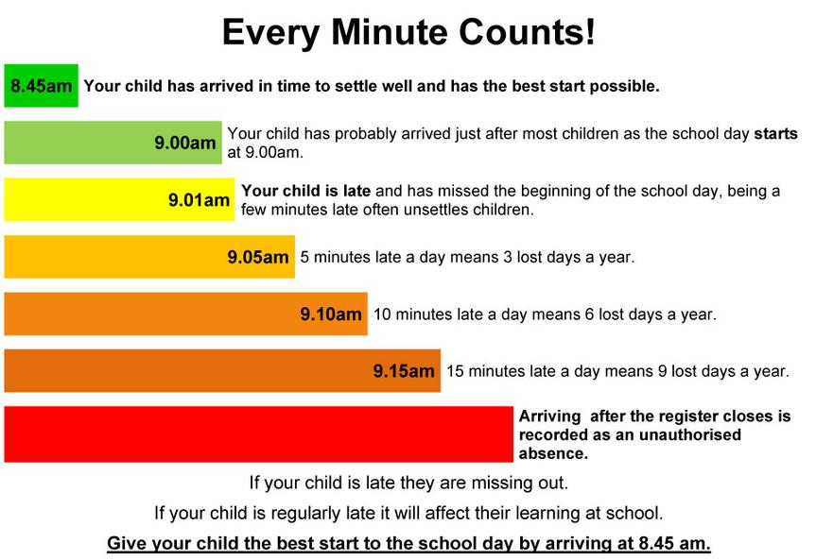
If you need help with achieving high attendance please let us know. We are here to help!

For more information please go to:
www.gov.uk/school-attendance-absence
www.bbc.co.uk/schools/parents/school_attendance
www.ace-ed.org.uk/advice/attendance

